GIFT AID DECLARATION
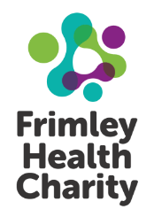
Boost your donation by 25p of Gift Aid for every £1 you donate!
Gift Aid is reclaimed by the charity from the tax you pay for the current tax year. Your address is needed to identify you as a current UK taxpayer.

In order to Gift Aid your donation you must tick the box below:

I wish to Gift Aid my donation of £_______________and any donations I make in the future or
have made in the past 4 years to Frimley Health Charity.

I am a UK taxpayer and understand that if I pay less Income Tax and/or Capital Gains Tax than the amount
of Gift Aid claimed on all my donations in that tax year it is my responsibility to pay any difference.

My details:

Title_______________________ First name or initial(s)___________________________________

Surname___________________ Telephone number_____________________________________

Address: _______________________________________________________________________

___________________________________________________ Postcode_______________________

e-mail address _______________________________________________________________________

Please notify the charity if you:
- Want to cancel this declaration
- Change your name or home address
- No longer pay sufficient tax on your income and/or capital gains
If you pay Income Tax at the higher or additional rate and want to receive the additional tax relief due to you, you must include all your Gift Aid donations on your Self-Assessment tax return or ask HM Revenue
and Customs to adjust your tax code.

The information provided by you to Frimley Health Charity will be held in strict accordance with The Data Protection Act 2018. Our privacy policy has more on this at www.frimleyhealthcharity.org/privacy-statement.
We would love to keep you up-to-date about news, our fundraising campaigns and events, and the changes you are helping to achieve. We promise not to overwhelm you! Please let us know your contact preferences below by ticking the relevant boxes:
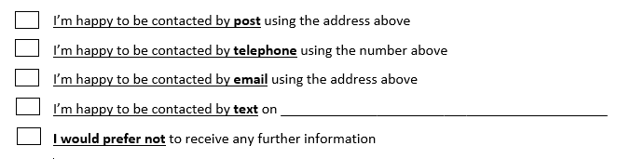

Signature ____________________________________ Date _____________________________

Frimley Health Charity, Frimley Park Hospital, Portsmouth Road, Frimley, Camberley, GU16 7UJ
Registered charity no. 1049600
Tel 0300 615 3206 frimleyhealthcharity.org fhft.fundraising@nhs.net

