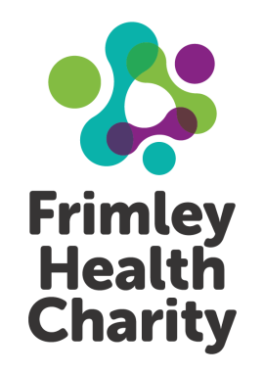
Frimley Health Charity
Registered Charity No: 1049600

GIFT AID DECLARATION - Multiple Donations
Boost your donation by 25p of Gift Aid for every £1 you donate

Gift Aid is reclaimed by the charity from the tax you pay for the current tax year. Your address is needed to identify you as a current UK taxpayer.

In order to Gift Aid your donation you must tick the box below:

I wish to Gift Aid my donation of £_______________and any donations I make in the future or
have made in the past 4 years to Frimley Health Charity.

I am a UK taxpayer and understand that if I pay less Income Tax and/or Capital Gains Tax than the amount
of Gift Aid claimed on all my donations in that tax year it is my responsibility to pay any difference.

My details

Title_______________________ First name or initial(s)___________________________________

Surname___________________ Telephone number_____________________________________

Address: _______________________________________________________________________

___________________________________________________ Postcode_______________________

e-mail address _______________________________________________________________________

Please notify the charity if you:
- Want to cancel this declaration
- Change your name or home address
- No longer pay sufficient tax on your income and/or capital gains
If you pay Income Tax at the higher or additional rate and want to receive the additional tax relief due to you, you must include all your Gift Aid donations on your Self-Assessment tax return or ask HM Revenue
and Customs to adjust your tax code.

The information provided by you to Frimley Health Charity will be held in strict accordance with The Data Protection Act 1998. We would love to keep you up to date about news, our fundraising campaigns and events, and what you are helping us achieve. We promise not to overwhelm you with communications. If you’re happy for us to do that, please fill in your relevant contact details below:

I’m happy to be contacted by post using the address above
I’m happy to be contacted by telephone using the number above
I’m happy to be contacted by email using the address above
I’m happy to be contacted by text: _______________________________________________________
I would prefer not to receive any further information

Signature ____________________________________ Date _____________________________________

Please make cheques payable to Frimley Health Charity and send to
Frimley Health Charity, Frimley Park Hospital, Portsmouth Road, Frimley, Camberley, GU16 7UJ
Tel 01276 604642 www.frimleyhealthcharity.org

